Linux Questions

Q1:Show me current directory

Q2:Who is the current user

Q3:Create single empty file

Q4:Create multiple empty files

Q5: A user created a file using touch file1.How can you show the size of the file

Q6: When is the file created.where can we check the timestamp

Q7: Create directories and sub directories as shown below

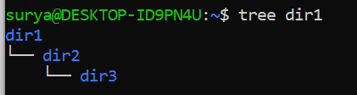

Q8: Suppose I have 2 directories as shown below

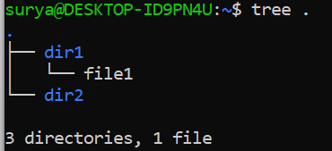

I want only file1 to be copied to dir2

Command:?

I want to copy entire directory dir1 to dir2

Command:?

Q9: What happens

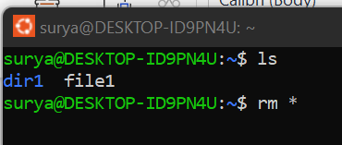

Q10: I have to delete all the files as shown below but I should not use

rm a\* or

rm a1 a2 a3-------

What is the other way to delete. a1 to a10 are the only files present in the current directory

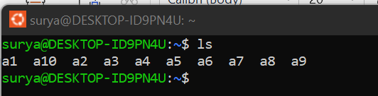

Q11: I have to delete the below files but should not use

rm absurya1 cdsurya2 efsurya3

How can I do it

Should not use rm \*

What is the other way

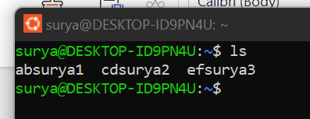

Q12: I have 2 directories d1 and d2. I want to copy d1 data into d2. Will the below command work

Cp d1/\* d2

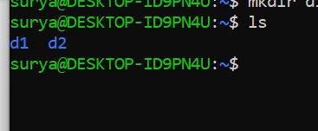

Q13: When the user is running is tree command to check the directories and sub-directories present .The user is unable to run tree command what might be the issue

Q14: I.What is the difference between useradd and adduser

II. Linux admin has created a user using “adduser user1”

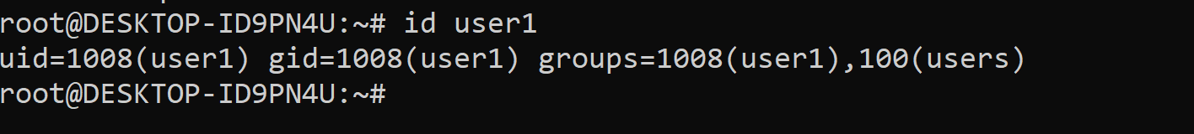

What is uid,gid and groups in above output

III. Can I change the primary group or default group of user1.

If yes command:

IV. Can I change the secondary group of user1

If yes Command:

Q15: Admin has created a user by name surya.How can we find whether is created or not

Q16:Suppose a user is added by using adduser user1

Will “userdel user1” also deletes the /home/user1 directory or it still exists

Q17: What is booting process in Linux

Q18:What do you mean by root user and normal user

Q19:I have a file as shown below

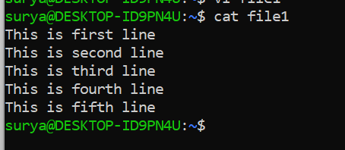

I want to print first 2 lines command:

I want to print last 2 lines command:

I want to delete last line command:

I want to print 2nd and 3rd line command:

I want to count the number of lines:

I want to empty the file without opening in vi editor Command:

I want to delete only 3rd line

I want to delete 1st to 3rd line opening in vi editor

Command:

I want to check the line number that has “second”

I want to print other lines except the lines that has “third”

Q20: I want to check the Linux-OS full details where can I see it.

Q21: How can I compress

1. only multiple files
2. Files and empty directories
3. Files and nonempty directories using zip

Q22:Identify the mistake

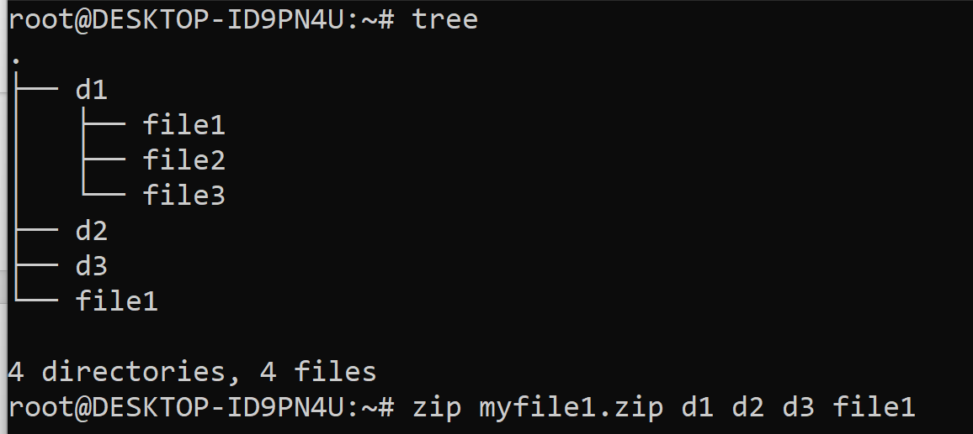

Q23:What is tar and gzip and write the commands how we use tar and gzip

I How to compress

II How to extract

Q24:Can we use gzip for directories or is it used only for files

Q25:Why do we prefer linux to windows in DevOps

Q26:I want to check the running process CPU and Memory usage.

Q27: I want to forcefully terminate a running process what can I do

Q28: A developer has coded below

for(i=1;i>0;i++)

print I

Which went into infinite loop as I Value is initialized with 1 and incremented by 1 which will never come out of the loop.. …We need to end the infinite loop as it is using excess CPU and memory what is the process we need to follow.

Q29: What is difference between top and htop command

Q30: I want to check the storage of entire system. What can I do

Q31: I want check the file and directory size other than ls -l

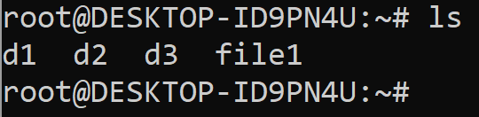

Q32: What is the use mount and umount command in Linux.

Q33: I have a file by name “file1” in one of the 10 directories d1 to d10.

I am not sure in which directory the file is present which is the best method to find the file

1. Opening each directory and ls -l file1
2. Using tree command
3. Using find command
4. Using locate command

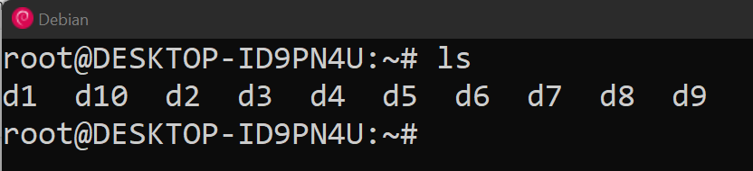

Q34: Who is the user owner and group owner of d1 and file1

I I want to change only user owner to surya of directory d1

II I want to change only group owner to surya of file file1

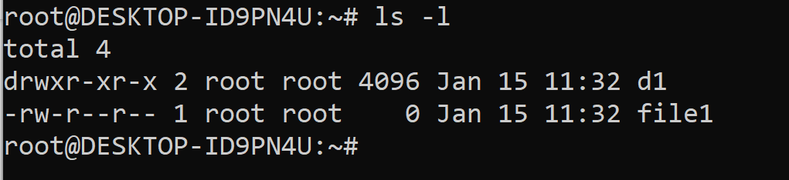

1. How can we change back the ownership both user and group to root again

Q35: I have a directory d1 as shown below

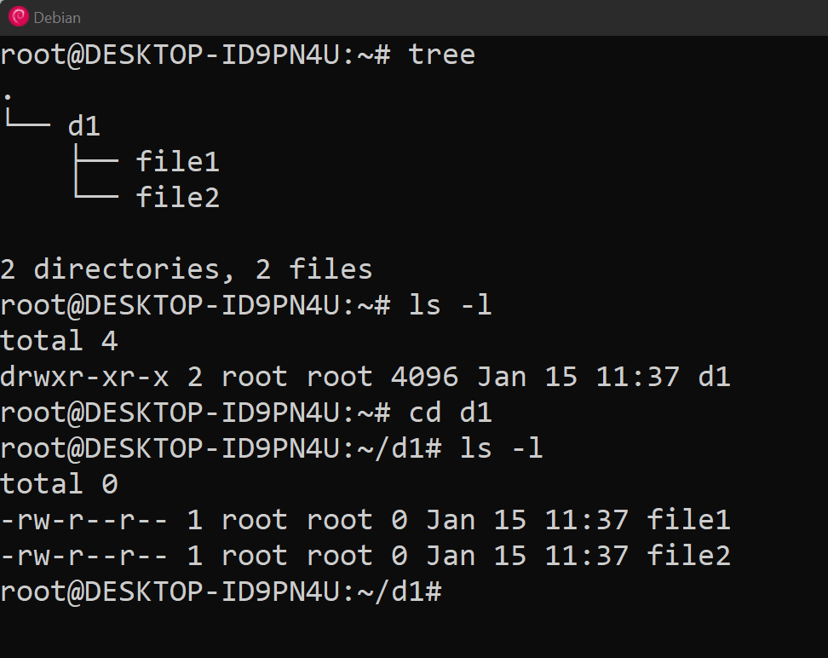

1. How can we change d1 ownership to user1 and keep file1 and file2 owner as root itself
2. How can we change entire d1 and its child directories,files to user1

Q36: What is the use of ping,ifconfig and ip addr show command

Q37: What is the use of dig command

Q38: What is the use of traceroute

Q39: Chmod:

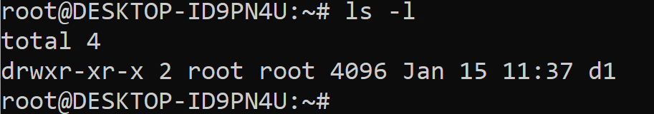

1. What is the default permission of directory
2. What is the default permission of a file
3. What is umask in linux
4. I want to give only read permission to user ,only write permission to group and execute permission to others (Use u,g,o not numbers)
5. Same as IV but use numbers
6. I want this permission “r---------” to d1 how can I get this
7. I want “--------x” to d1. What is the command.
8. I have a file with “rwxrwxrwx” permission I want to delete executable permission to all how can I do it  
   IX.I want to give “rw” to user,”wx” to group,”r-x” to others How can I get this

X.What is the meaning of below command?

Chmod 712 filename

Chmod 271 dirname

Q40: Explain the directory structure of linux

I bin II boot III opt IV root V home VI etc VII dev VIII media IX tmp X mnt XI var